Canadian Charter of Rights and Freedom Picture Essay

The Polar Environmental Atmospheric Research Laboratory

http://www.theglobeandmail.com/news/national/the-north/how-canadas-arctic-lab-keeps-a-watchful-eye-on-climate-change/article16423612/

Canada’s *Charter of Rights and Freedoms* contains the provision that Canadians have the freedom of thought, belief, opinion and expression, including freedom of the press and other media of communication. In this photo we can see a Canadian Arctic research laboratory where scientists can study the effects of climate change without the fear of the government silencing or preventing their research from reaching the media and the world.

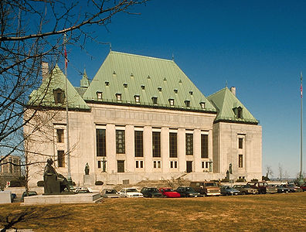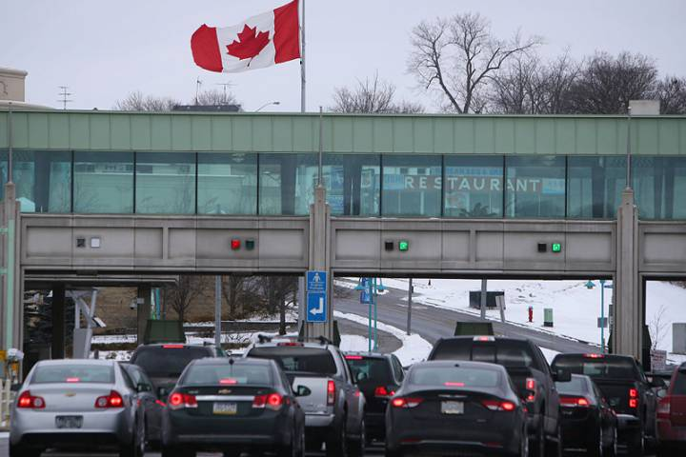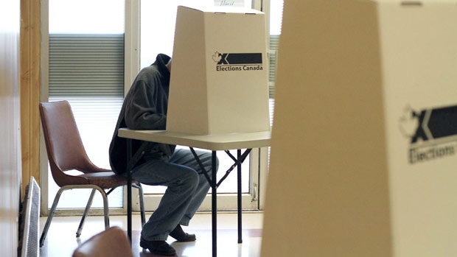

Supreme Court of Canada

<http://www.thecanadianencyclopedia.ca/en/article/supreme-court-of-canada/>

The *Charter of Rights and Freedoms* guarantees the right in court to be presumed innocent until proven guilty according to law in a fair and public hearing by an independent and impartial tribunal. In this photo we see the Supreme Court of Canada which when takes criminal cases it must abide by the previously mentioned provision that every defendant must be assumed innocent until proven guilty to have a fair trial.

Canada-United States Border Crossing

<http://globalnews.ca/news/3075089/new-immigration-rules-make-it-easier-for-americans-to-work-and-stay-in-canada/>

The *Charter of Rights and Freedoms* gives Canadians the freedom to enter, remain in and leave Canada. This is a photo of the Canadian border crossing showing many people leaving and entering each country because they have the right to do so as long as there is no criminal intent, in some societies citizens do not have this ability and are stuck to say in a country even if they are oppressed and have a terrible life they cannot leave.

Canadian Voting Booth

<http://www.cbc.ca/news/politics/having-young-kids-keeps-canadians-from-voting-booth-1.1242688>

Under the *Canadian Charter of Rights and Freedoms* Canadians are guaranteed the right to vote in an election for the members of the House of Commons. In this photo we can see a person voting in one of the Elections Canada voting booths the provision number 3 in the *Charter of Rights and Freedoms* allows this person and all Canadians citizens over the age of 18 to vote and elect members to the House of Commons.

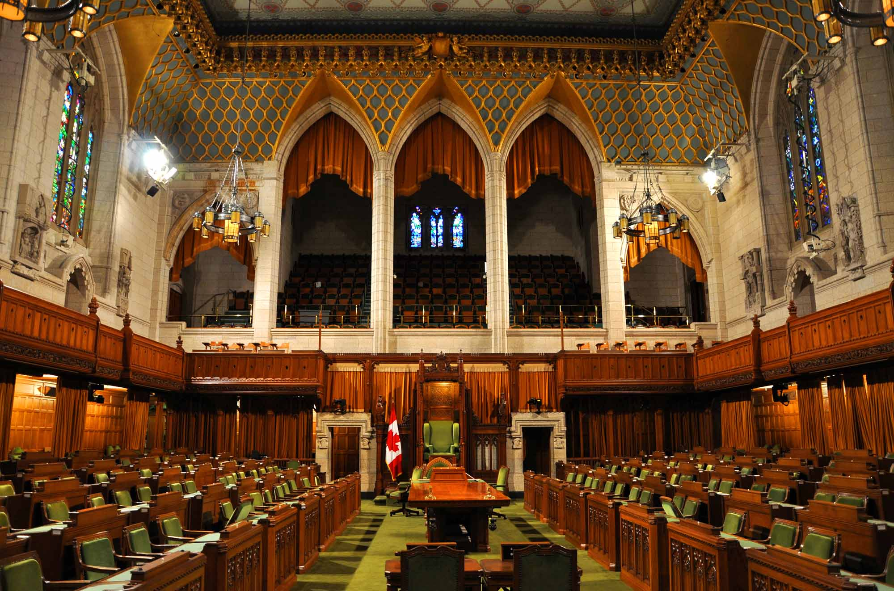

Canadian House of Commons

<http://www.thecanadianencyclopedia.ca/en/article/house-of-commons/>

Under the *Charter of Rights and Freedoms* no legislative assembly may continue for 5 years without an election. In the House of Commons this is critical to the importance of this office if the members could gather for more than 5 years then the government could turn into a dictatorship however the *Charter of Rights and Freedoms* prevents that from happening.



Occupy Wall Street Protesters in Toronto

<http://www.cbc.ca/news/canada/occupy-canada-protest-plans-take-shape-1.977190>

The freedom of peaceful assembly is guaranteed in the Canadian *Charter of Rights and Freedoms*. This right allows the protesters in this photo who are protesting the wealth inequality in Canada to protest without fear of the government intervening or attempting to prevent the protest from happening as long as the protest is peaceful and nonviolent.



Ottawa Catholic School Board Education Centre

http://www.ottawasun.com/2014/12/09/ottawa-catholic-school-board-settles-gay-rights-fuss

The rights of religious schools to exist is protected under the *Charter of Rights and Freedoms.* In this image you can see the Ottawa Catholic School board which is given the ability to exist through the charter which allows the board to practice its religious beliefs without government intervention or prevention.

Supporters of the Communist party march at Pride parade in Toronto

<http://www.macleans.ca/general/toronto-pride-mulcair-bears-caucus-size-leadership-hopefuls/>

Every Canadian citizen is given the freedom to associate with any person or political party this is a right that is written in the *Charter of Rights and Freedoms.* This image shows supporters of the Communist Party of Canada marching in the pride parade, Communism is a heavily criticized ideology and is against the stance of the government however the government cannot do any harm to these supporters under the *Charter of Rights and Freedoms*

